**ANALYSIS OF ONLINE RETAIL STORE II DATA**

Throughout the analysis of the dataset, I have taken a question-answer based approach to understanding the data. Below are the insights I gained from the analysis:

* The dataset contains approximately **526 thousand** purchase records with **WHITE HANGING HEART T-LIGHT HOLDER being the most purchased product category (57733 times).**

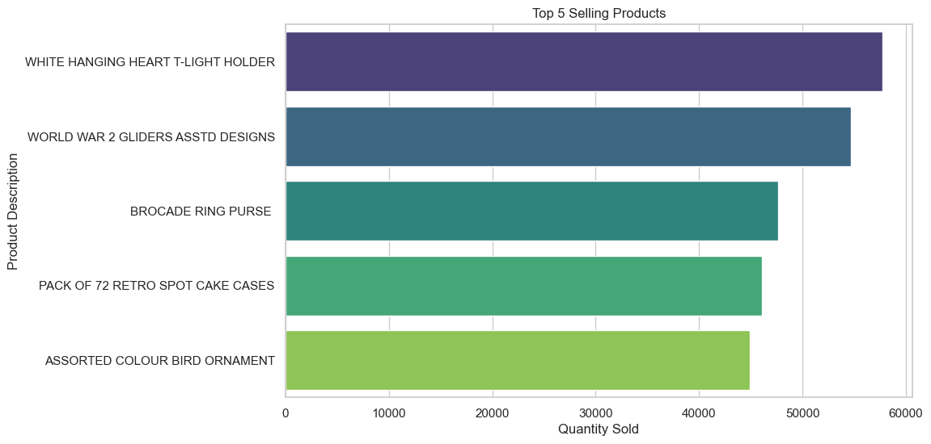

* **REGENCY CAKESTAND 3 TIER** and **WHITE HANGING HEART T-LIGHT HOLDER** are the top purchased products by total sales

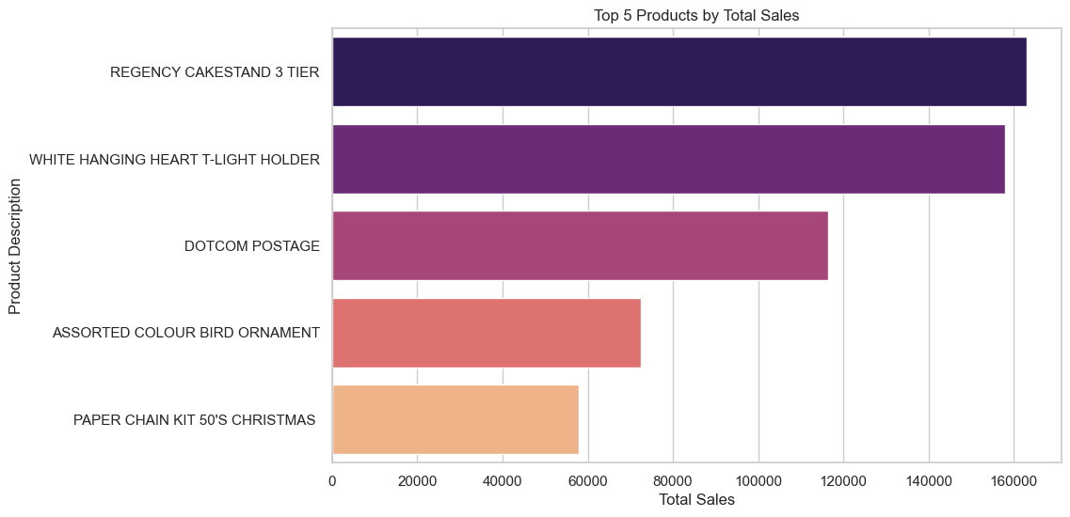

* The total number of products sold in 2010 was significantly higher.

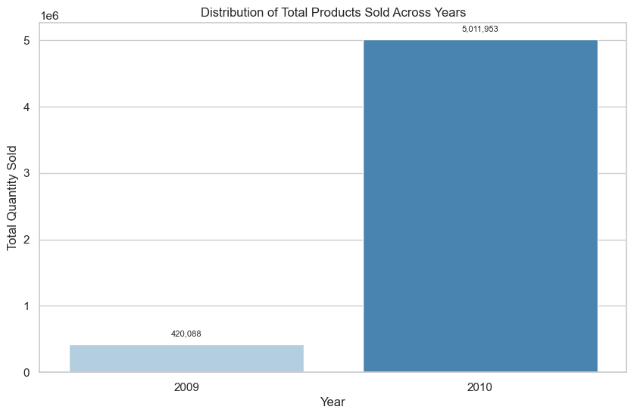

* Across 2009 and 2010 combined**, the highest number of product appear to be brought in the month of November.**

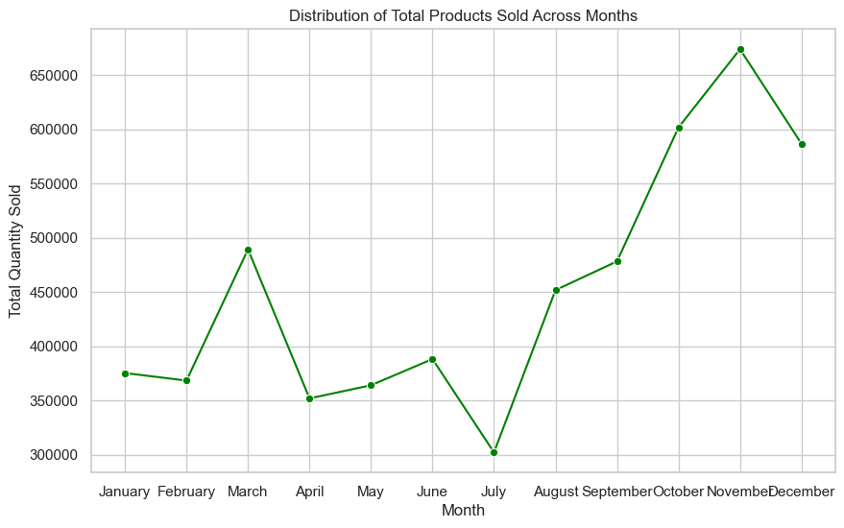

* Customer with id 18102 appears to be the highest spender

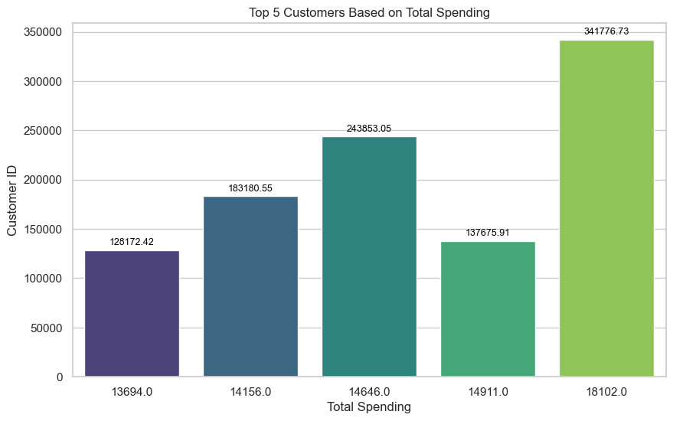

* The heatmap below answers the question **“do certain products sell better during specific months**?”. **BROCADE RING PURSE seems to be the best-selling product in September** while WORLD WAR 2 GLIDERS and BROCADE RING PURSE the best-selling in November and so on.

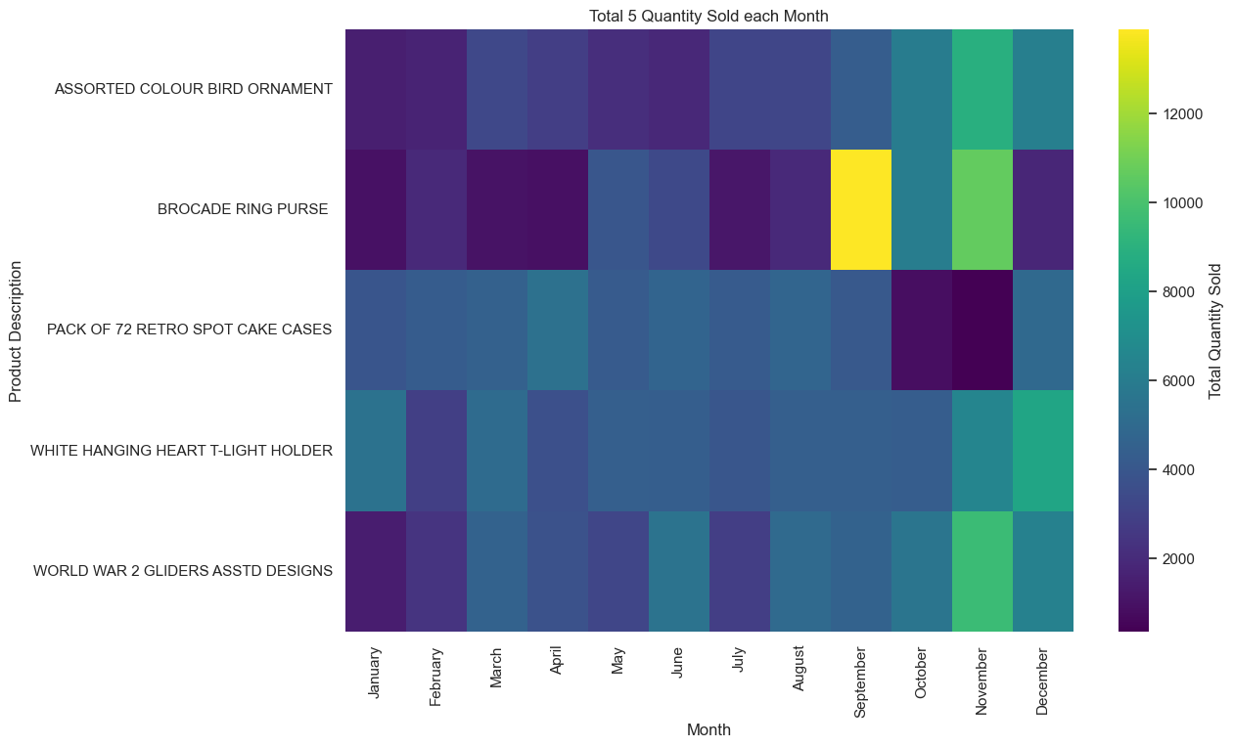

* There appears to be very less product sold in other countries. Majority of the total sales was completed in United Kingdom (92%). In addition, WHITE HANGING HEART T-LIGHT HOLDER are the most sold products.

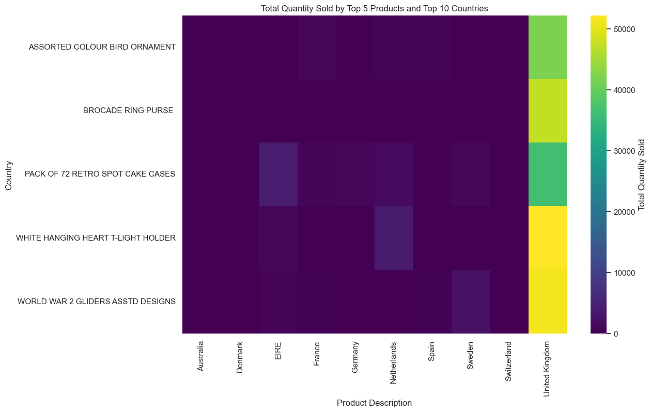

* Customer Clustering using Elbow method

